NEED TO PROVIDE ONE OF THE FOLLOWING AT THE EXPO FOR NEW PRODUCT ENTRIES: Options:
1) POSTERBOARD WITH STAND (ONLY SIZE is 8.5” x 11”). Due to limited space, we are asking ONLY for this size posterboard so they can all fit on the tabletop display.
2) YOU CAN PRINT OFF INFORMATIONAL SHEET OF NEW PRODUCT WITH FEATURES AND PICTURE OF IT AT OFFICE AND BRING STANDING PLASTIC HOLDER so attendees can view quickly. (EBMI does NOT provide sign holders and will lay them flat if company does not provide them at the show.)
3) Cut sheets are okay to use too, BUT contain TOO much information for attendees and judges on limited time to view them. If doing this please bring plastic sign holder for them.
4) ACTUAL PRODUCT SAMPLE at the expo (with cut sheets near product), but we know this isn’t always possible and NO SECURITY is provided at showcase area. The goal is to make them want to stop by your booth, so they can obtain additional info about the new product. EBMI will provide a sign showing only the booth#, company and product name by each new product entry’s space on tabletop at area to the left of the entrance for the Expo.
IMPORTANT TO JUDGES AND ATTENDEES: Please give BASIC VIEW OF FEATURES and do not use adjectives to describe your product over competitors (best, first, etc.) as they will be edited OUT of the description by EBMI on entry forms. Highlighting important features simply will allow attendees and judges to quickly see your product and make note to head to your booth.
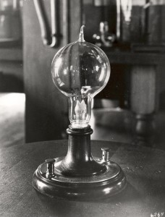
EXAMPLE OF WORDING TO KEEP THIS SIMPLE IS BEST … FOR NEW PRODUCT ENTRIES AND POSTERBOARD OR INFORMATION FORM TO BRING FOR SHOWCASE AT THE EXPO:
EDISON ELECTRIC LIGHT CO.
Product: “INCANDESCENT LIGHT BULB”
Date of new product: 11/1879

FEATURES making it unique to the industry:
- Safe lighting which replaces gaslight.
- Use of carbon filament instead of platinum that provides material of higher resistance.
- A sustainable light that lasts for 14.5 hours.

